Introduction:

In this project we will learn how to use Gephi to create a diagram showing the relative importance of characters’ relationships in Victor Hugo’s novel Les Miserables. Note that for this example, our data set already exists. For your own project, you’ll most likely need to set aside some time compiling your data.

Project due date:

[_____]
Other project requirements:

How to build it:

- Start Gephi:
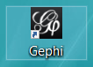

- Download and save the Les Miserables data file (on the Gephi Welcome page):

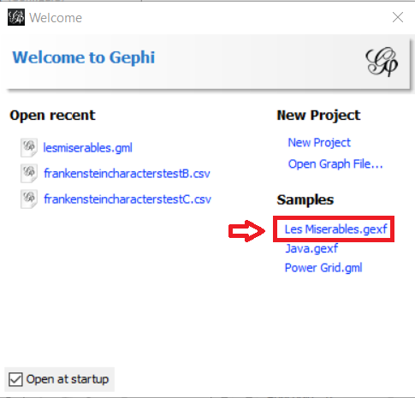
- Under New Project, Click Open Graph File:

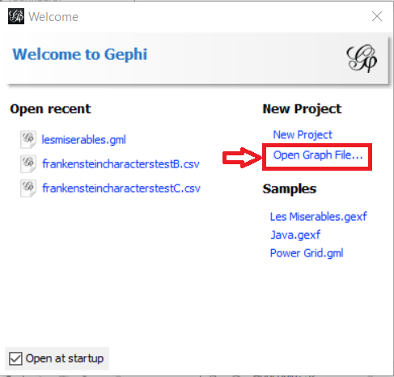

- Navigate to and click on the local copy of the Les Miserables data file that you just downloaded.
- Click the drop-down under Graph type; 2) select Undirected; 3) click OK:

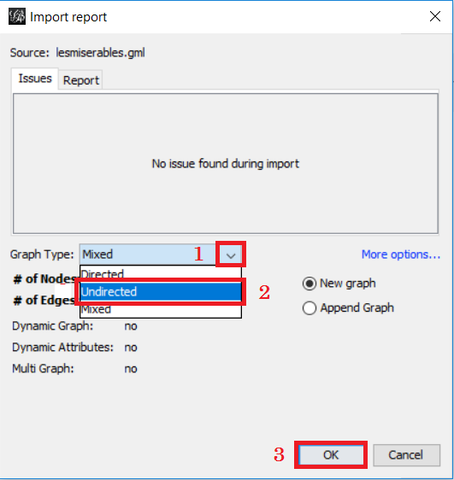

- Click the Data Laboratory tab at top of the window:
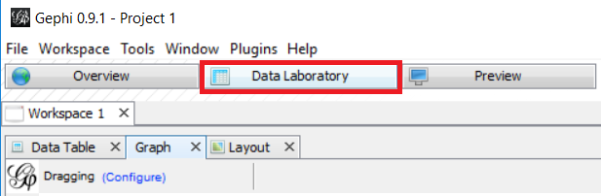
- 1) Click the Window tab at top of the screen; 2) Select Layout:
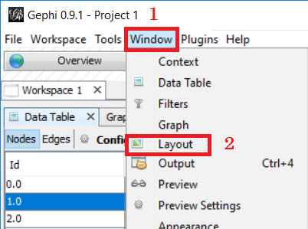
3) Click on the Choose a layout drop-down and select Force Atlas:
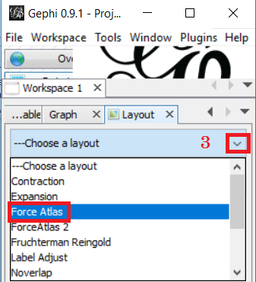
4) Click Run, then 5) change the Repulsion strength value to 20,000 and click Run again:
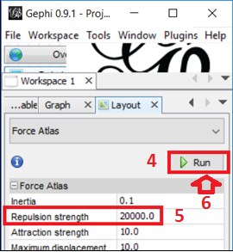
- Go back to the Overview tab and click the Appearance panel on the left side of the window. Make sure the Palette icon--
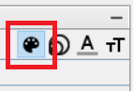
--is selected.
- 1) Select Attribute, 2) click the drop-down Choose an attribute, and 3) click on Degree.
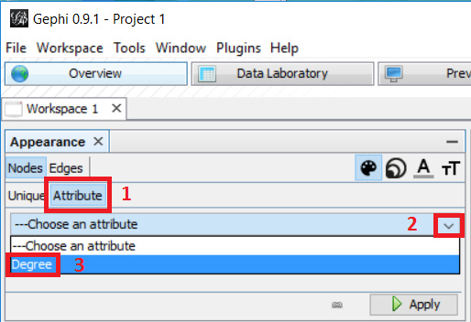

- Click on the small, square-shaped Gradient Selector panel to the right , then select a gradient --you may have to hover over the Default menu-pick as shown here--
and click Apply:
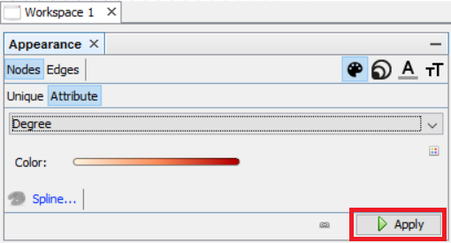
NOTE: “Degree” in this context is creating a gradient from least-connected nodes to most-connected nodes. After you have applied a gradient, nodes with the most connections (“edges”) will be given a darker color on your network diagram, indicating the relative strength of the relationship.
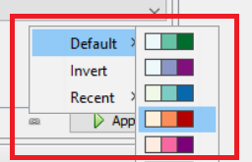

- Now go to the Statistics panel on the right side of the Gelphi window, page down and click Run on the Avg. Path Length panel. Hit OK when the prompt comes up and close the Graph Distance Report that pops up afterwards.
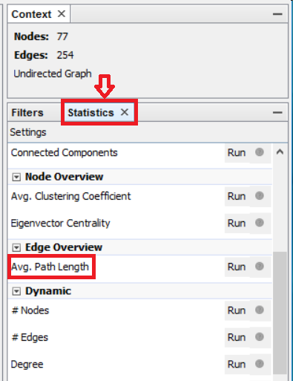 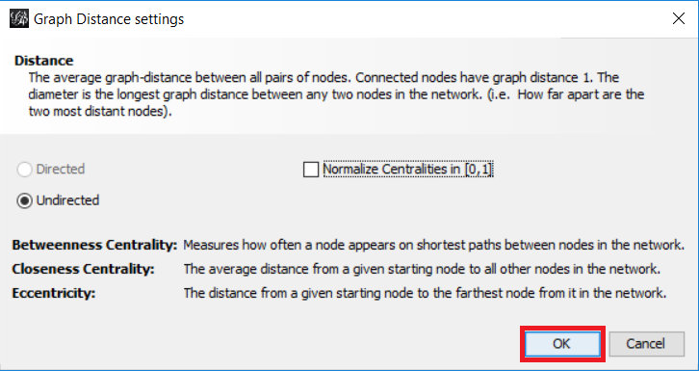

- On the Appearance panel, click on the Size button (the concentric circles) 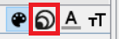 . Click on Attribute, then click the drop-down and choose Betweenness Centrality—make the minimum size 10 and the maximum size 50--
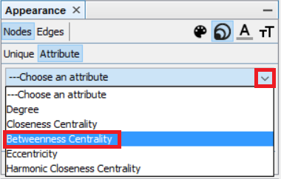
NOTE: In statistics, “Betweenness Centrality” is an indicator of a node’s importance. For our example, applying this feature allows Gephi to proportionally represent nodes according to their importance/connections.

- Now go down to the Layout panel and check the Adjust by Sizes box to create a bit more separation for the labels:
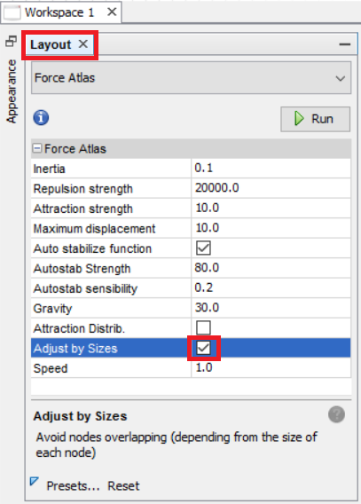

- Click Run 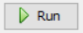 and then click Stop 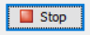.

- 1) Click the Graph tab, then, 2) on the bottom toolbar, click the Show Node Labels button (the black “T”) to show the names of the characters represented by each node. To make the text proportional, 3) click on the Size Mode drop-down (the black “A”) and select Node Size.
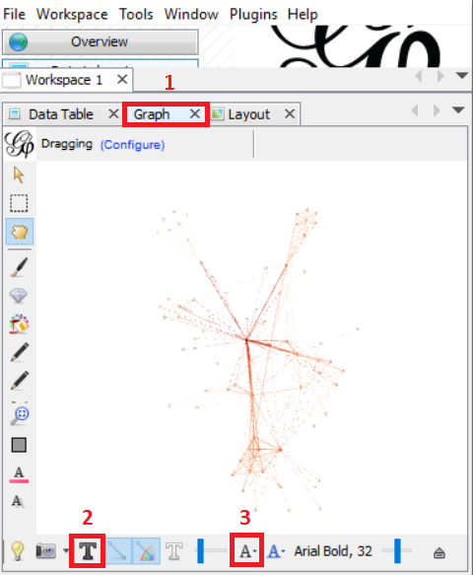

- Now go back to the Statistics panel (behind the Overview tab) and click Run on the Modularity line.
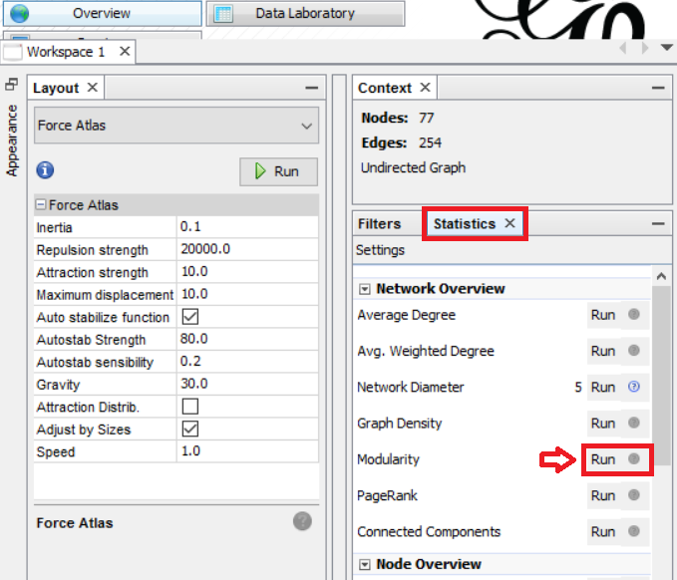

- Click OK and close the “Modularity Report” graph that opens afterwards.
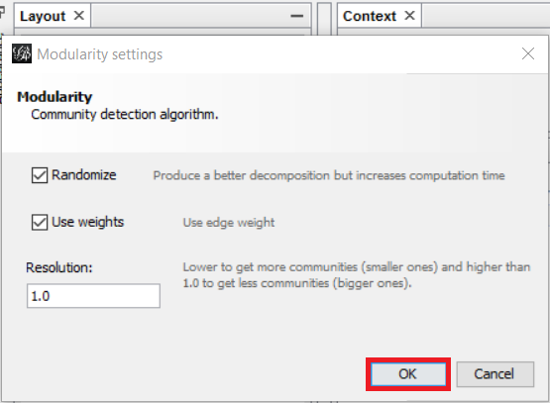
- Click Window > Appearance, select the Attribute tab, then click the drop-down and select Modularity class and click Apply. (In Gephi, “Modularity” denotes the working clusters within a network. The Modularity attribute color-coordinates the major groups within this particular narrative to show the networks within the network.)

- To see how your graph is shaping up, click the Data Laboratory tab at top of the window, then click Graph. If your network diagram has too many data points to be intelligible, you can adjust the number of edges each node must have in order to be visible in the network. To do that, click the Overview tab, then select Filters from the right-hand panel. Click the Topology folder to open it, then select Degree Range, and drag it down to the Queries box.
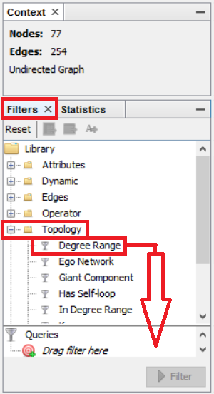
From there, move the slider to 3 and click on Filter:
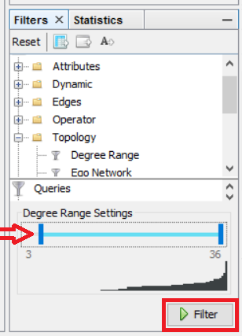
Each node must now have at least three edges in order to be visible in the network.

- Now we’re going to save an image of our network diagram. Click on Preview near the top of the program.
Hit Refresh. Check off Show Node Labels and hit Refresh.
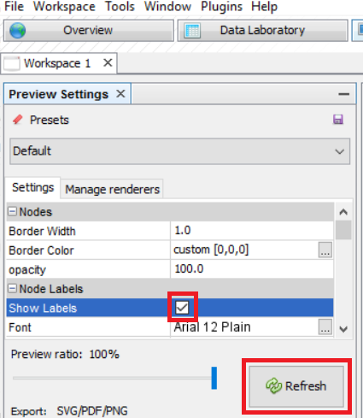
- Change preset from Default to Black Background and hit Refresh.
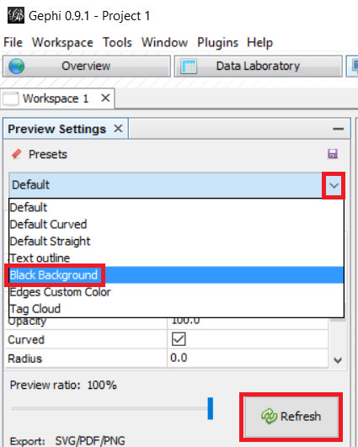
Click on File>Export>Graph to save a “CSV” (comma-separated values) spreadsheet file containing the values of your network. This will allow you to reproduce and modify the diagram later.

