Introduction:

A timeline is a graphic representation, usually along a horizontal axis, of a series of related historical or planned events. Timeline JS3 is an open-source timeline development tool sponsored by Northwestern University. (The JS stands for javascript, the programming language in which this application was written. The 3 refers to the most recent release of the software.)

Knowing how to build, update and interpret a timeline is a useful skill in many fields. In academia, a timeline can be a good choice of information type if you want to locate events in the context of larger historical trends, show concurrency and infer causation, or just add a rich visual component to your audience’s understanding of events. In business, timelines help managers track overall progress, isolate dependencies, and identify problem areas in complex projects.

There are many web-based timeline tools available. We recommend Timeline JS3 for the following reasons:
- It is platform-agnostic (on the Web, so all you need is a computer that connects to the Internet).
- It has a lot of capacity.
- The output looks like a professional information product—not too much frill.
- It can be easily updated.
- It’s open-source (free) !
To build a Timeline JS3 timeline, you’ll need an internet connection, a Google account, dates of and information about the key events you want to depict, and access to the multimedia objects (images, video, music, etc.) you wish to add to each event.

Project due date:

Other project requirements:

NOTE: For this exercise, you’ll need an account on Google.
IMPORTANT: If you are uncomfortable identifying yourself online as a student at University of Puget Sound, we recommend you create a new Google account with an alias. (One option is to divide your first name into two parts, e.g., first name Tim, last name Othy.) This way you maintain your anonymity to the online world. Google doesn’t care what name you use, as long as there’s a first and last name of some sort.
Plan to use Mozilla Firefox as your browser (since Timeline JS3 doesn’t always play well with Internet Explorer). You will also want to have already done your research on your first few events and gathered the relevant information you’ll be adding to the timeline. (See Step 8 below for details.)

Step 1: Go to www.timeline.knightlab.com and select New! Try the TimelineJS 3 Beta:
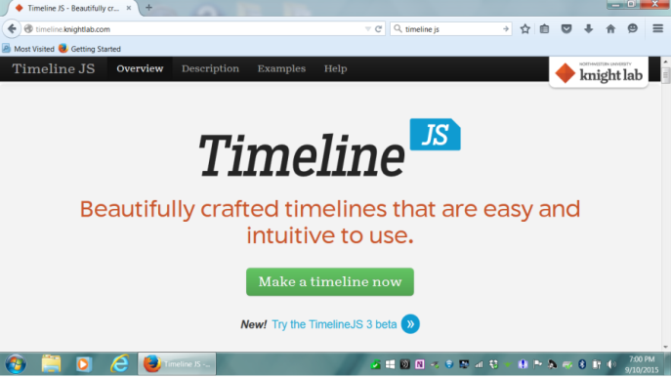
Step 2: Select Make a Timeline:
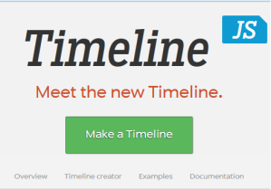
Step 3: Select Google Spreadsheet Template:
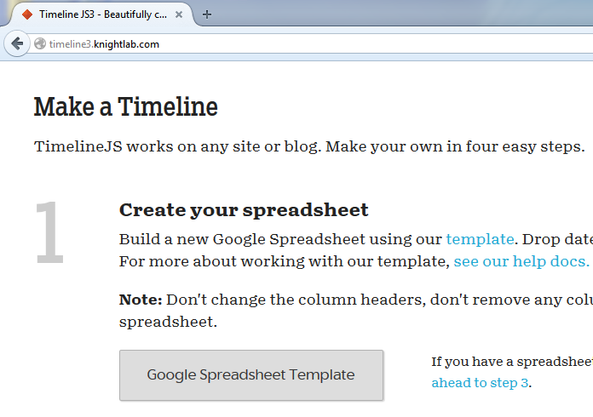
Step 4: Select Go to Google Drive:
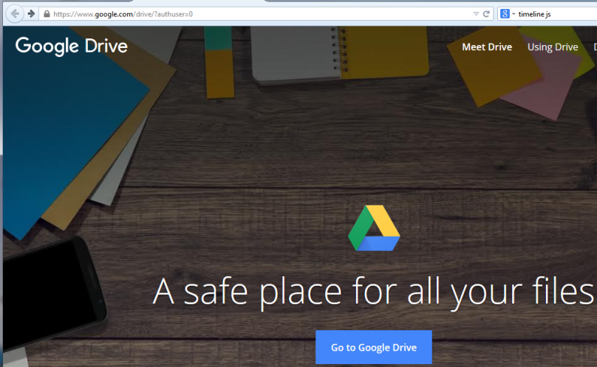
Step 5: Log on to your Google account (with your new false credentials, if you have them).
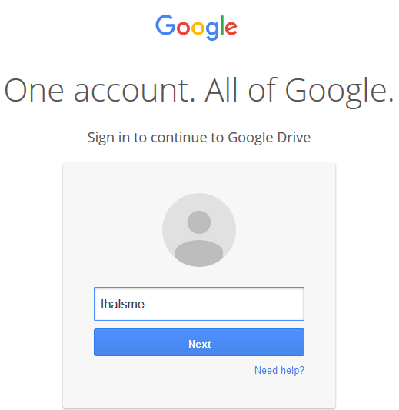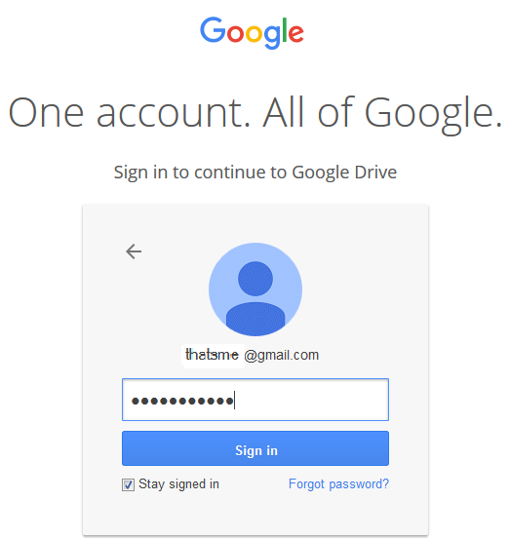

Step 6: On Google Drive, find and open the file “Copy of Official TimelineJS3 Template.”
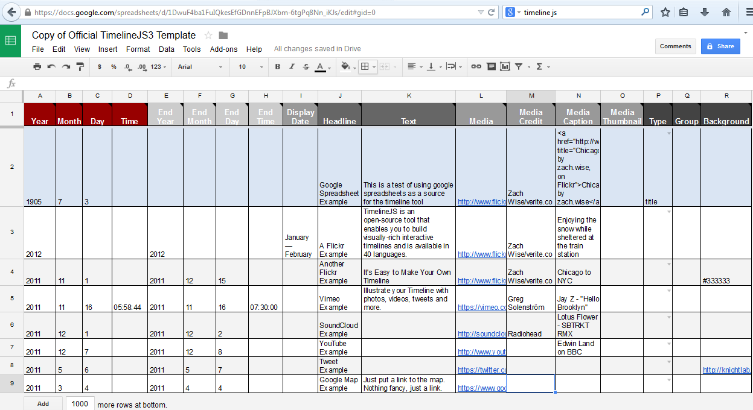
Step 7: Select all the cells in your copy of the template except the header row (hold down the left button on your mouse and move the cursor across and down the spreadsheet), then select Edit > Delete values:
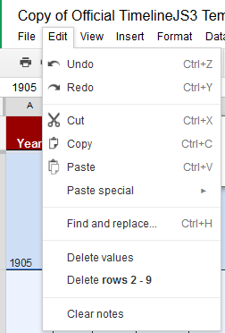

That should give you a blank worksheet that looks something like this:
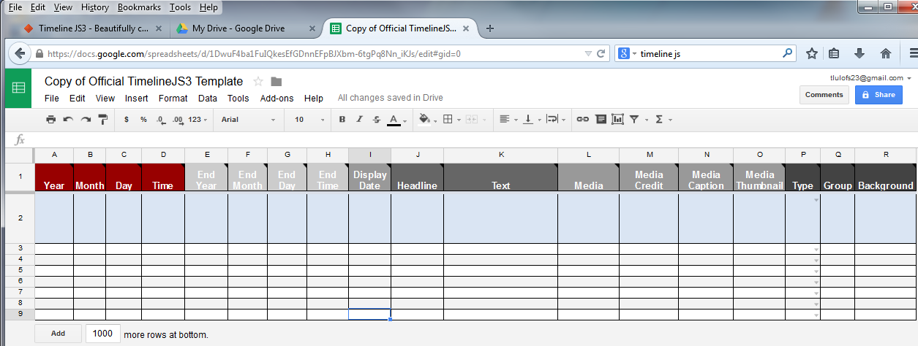
Step 8: For each event on your timeline, add the following information to your spreadsheet:
In Column A: The year your event occurred. Numeric values only!
In Columns B and C: (optional) The month and day (if you have that information and want to include it). Numeric values only!
In Columns E-H: (optional) The year (and in some cases month and day) when the event ended, if you have that information and if it makes sense to include it. (For instance, the Thirty Years’ War would require entries in both the Start year and the End year columns.) Numeric values only!
In Column J: A short descriptive phrase identifying the event in question as it is usually referred to, e.g., The Thirty Years’ War.
In Column K: A description of the event that covers, in a few (complete) sentences, what happened, who the principal actors were, and why the event is considered significant in the context of the era or historical phenomenon your timeline covers. I recommend limiting your text to no more than 200 words; otherwise your text will spill below the page.
Important: The text in this column should be your own prose, not a cut-and-pasted excerpt from an online source. However, you will need to cite any source(s) you have read as part of your research that contributed to your understanding of the event. A typical in-text citation consists of author and page number (Smith 122) or just the page number if the author has already been mentioned in the text. You will also need to include a Works Cited “event” at the end of your timeline that provides fuller bibliographic information about all your sources. (See the discussion of sources and citation methods at the end of this handout.)

In Column L: The full URL (web address) of a publicly accessible image that is compelling in its own right and that is directly relevant to the subject.
In Column M: The source of the image.
In Column N: A caption describing the image (ideally, taken from your source).
In Column O: The same value as what you put into Column L.
In Column P: Leave this cell blank unless this is your timeline’s title page. In that case, select title from the dropdown.
In Column Q: You can leave this cell blank, or, if this event is one of several that fall into the same subcategory (such as “The Reformation”), add the category here.
In Column R: Either one of two possible values can go here:
- The hex code of a color to use as background for this panel. Go to http://www.w3schools.com/tags/ref_colorpicker.asp to get a look at the codes for an assortment of possible colors.
OR
- If this is your title page (and you’ve indicated that in Column P), the full URL of an image you want to use as background for your title page.
Don’t forget to include a Works Cited page as the last “event” on your timeline. (Use the current year as a (numeric!) value in the Start Year column for this “event.”)
Step 9: Select File > Publish to the web > Publish:
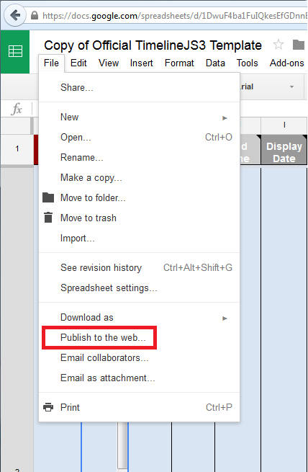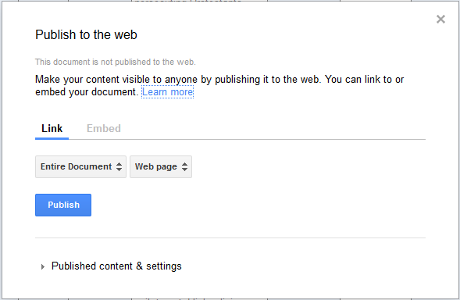

Step 10: Copy the URL of your file by selecting the URL string and hitting Ctrl+ C:
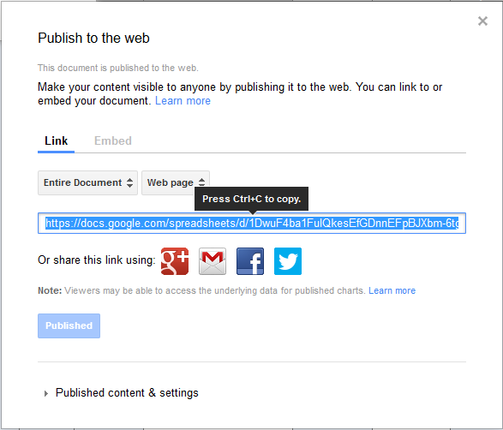
Step 11: Back on the TimelineJS web page, paste the URL you copied into the generator box, as shown:
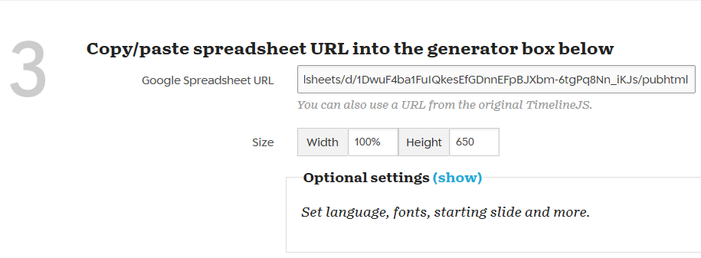
Step 12: Click Preview to take a look at your handiwork. If you see something you want to change, go back and make changes in the Spreadsheet and select Preview again to see the result.

On sources:
Over the next several semesters you will likely get a lot of instruction and practice in doing scholarly research. Meanwhile, for this assignment, keep in mind that there are good and not-so-good sources of information for academic projects. The Collins Library, like those at most universities, has access to vast collections of print and online resources that have been vetted by specialists and that meet the criteria for use in legitimate scholarship. These resources are literally at your fingertips.
The point is that it’s just as easy (and a lot more efficient) to go to authoritative sources when you’re doing academic research than it is to settle for a Wikipedia entry, which may or may not be substantive. Here are just a smattering of the many reputable online databases available through our library’s subscription services. You’re paying for them, so why not use them?
- The Oxford Reference Collection: http://www.oxfordreference.com.ezproxy.ups.edu/
- SAGE Reference Online: http://sage-ereference.com.ezproxy.ups.edu/
- The Gale Virtual Reference Library: http://go.galegroup.com.ezproxy.ups.edu/ps/start.do?p=GVRL&u=taco25438&authCount=1
- Literature Resource Center: http://go.galegroup.com.ezproxy.ups.edu/ps/start.do?p=LitRC&u=taco25438&authCount=1
And when in doubt, ask a librarian. They’re the experts.
On citations:
Click here for details on how to cite print and online sources using MLA format:
http://www.pugetsound.edu/files/resources/4244_MLA_Color.pdf

